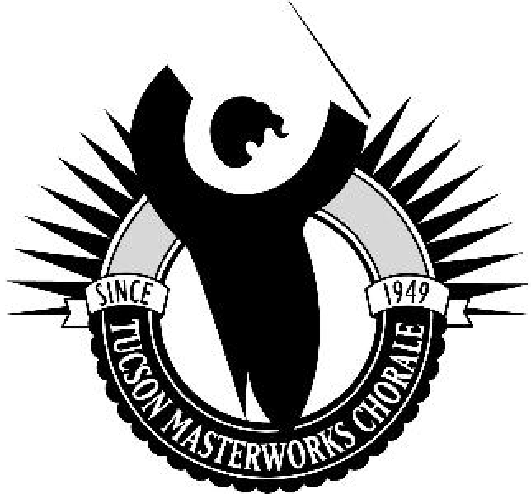
Tucson Masterworks Chorale
Fall’18 Program - Ad Guide
Borodin to Bernstein: Classics from the Stage
Sunday November 11, 2018
Grace St. Paul’s Episcopal Church, Tucson
Sunday January 13, 2019
Green Valley West Social Center, Green Valley
Our concert programs reach a diverse audience of over 1,000 arts enthusiasts!

Submit ads in electronic format to: Ads@TucsonMasterworksChorale.org, or give to TMC Chorale member.
Deadline for submission of Ads is Monday, October 15, 2018

Company or Name: Address:
Phone: Email:

TMC Member Name: Advertisement size; check one:

Zip:

Full page: outside back cover 7.5 x 4.25: $250 (Special Instructions)
Full page: inside front or back cover 7.5 x 4.25: $200 Full page: inside book 7.5 x 4.25: $150
Half page: inside book 4.25 x 3.5: $100
Quarter page: inside book (business card size) 3.5 x 2: $75

- Send artwork electronically to Ads@TucsonMasterworksChorale.org. Formats must be JPEG or PDF. Please note that our programs are printed in black-and-white/grayscale. To ensure your ad appears in a quality that best represents your company, please submit ads in black-and-white/grayscale images.
- Please make your check payable to “TMC.” Send your check along with this form to the address below. You may also return them to the person who contacted you.
- Artwork may be submitted CAMERA READY to the TMC member who contacted you or by mail; however, electronic submission is preferred.
Tucson Masterworks Chorale
P.O. Box 41885 Tucson, AZ 85717 (520) 625-8305

Deadline for submission of Ads is Monday, October 15, 2018

Tucson Masterworks Chorale is Southern Arizona’s oldest Community Chorus, bringing the Masterworks of choral literature to diverse audiences for over 68 years. The Chorale is a 501(c)(3) non-profit corporation, and operates with an all- volunteer Board of Directors.
Your support is always appreciated. Thank you!

TucsonMasterworksChorale.org facebook.com/TucsonMasterworksChorale twitter.com/TucsonMasterwks

